1. Import the Super store excel data into MySQL and store the data across three tables orders, people and returns
2. Connect Tableau Desktop to MySQL database
3. Import the joined data set of the aforesaid three tables through custom SQL

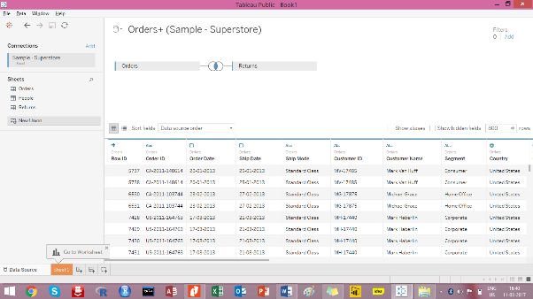

1. Rename the data connection as ‘my super store data’
2. Create an extract out of the data connection
3. Save the workbook as Super store dashboard.twbx